**Lab 3: Design a star topology using both hub and switch  in packet tracer.**

**Aims :**

* To design a star topology network using a hub and a switch.
* To connect multiple PCs to the hub and switch to create a network.
* To ensure connectivity between all devices in the network.

**Simulating Star Topology**

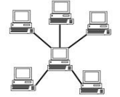

Star topology is one of the most common network setups .

Every node connects to a central network device in this  configuration, like a hub, switch, or computer. The central  network device acts as a server, and the peripheral devices act  as clients. In a star topology setup, either a coaxial or RJ-45  network cable is used, depending on each computer's type of  network card. The image shows how this network setup gets  its name, as it is shaped like a star.

There technically is no limit to how many computers can connect in a star topology. However,  network performance can decrease as more computers are connected, resulting in slower network  speeds.

**Procedure:**

**Star Topology simulation using switch as central network device:**

Process on Setting up a network in Cisco Packet Tracer

**Step 1: Select a central network device and any type of end-devices. I have chosen a switch  and Four**

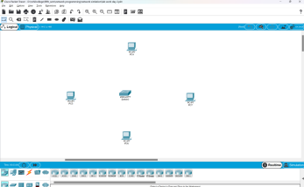

**Step 2: Link every device with the switch.**

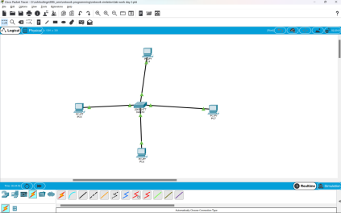

**Step 3: Provide the IP Address to every device.**

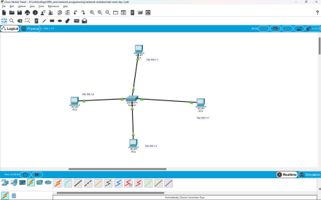

**Step 4: Check whether the connections are correct. I am trying to ping PC5 from PC1.**

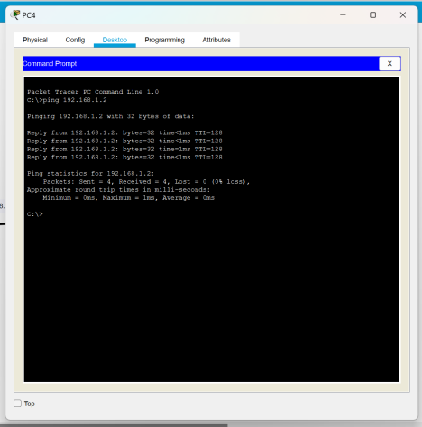

**Step 5: Transfer message from one device to another**

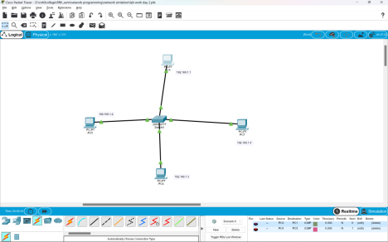

**Step 6: Transfer message from one device to another. Here I am trying to transfer packet  from “Laptop1” to “Laptop5”.**

First a packet is generated at “pc 4”. Then the packet is sent to “Switch0”.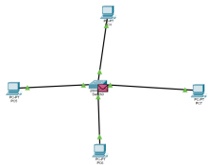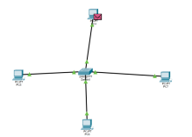

The “Switch0” sends the packet to the reviver only i.e. “pc 5”. When the receiver receives the  packet it sends acknowledgement message to “Switch0”.

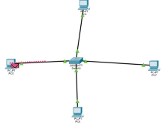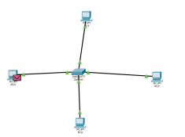

The acknowledgement message is again sent to the sender only ie. “pc 4”. 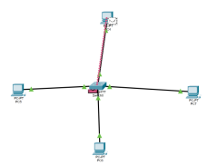

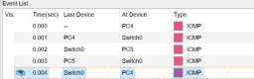

**Star Topology simulation using Hub as central network device:**

**Select a central network device and any type of end-devices. I have chosen a hub and ten  laptops. Connect each end device to central network device and configure the IP address of  each device.**

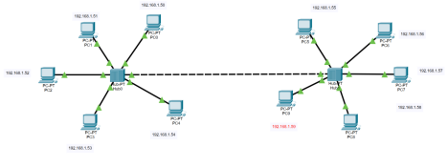

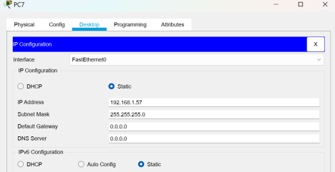

**Check whether the connections are correct. Here I am trying to ping “Laptop10” form  “Laptop3”.**

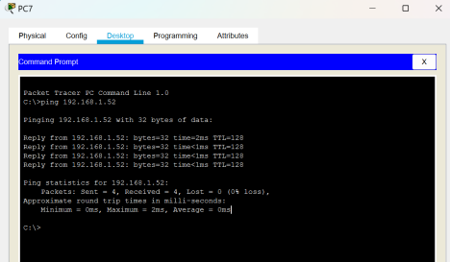

**Transfer message from one device to another. Here I am trying to transfer packet from  “Laptop3” to “Laptop10”.**

First a packet is generated at “Laptop3”.

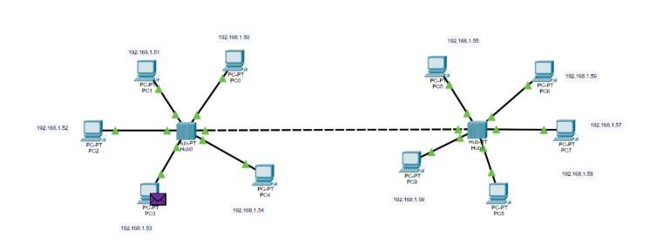

The packet is then sent to the immediate hub i.e. “Hub0”

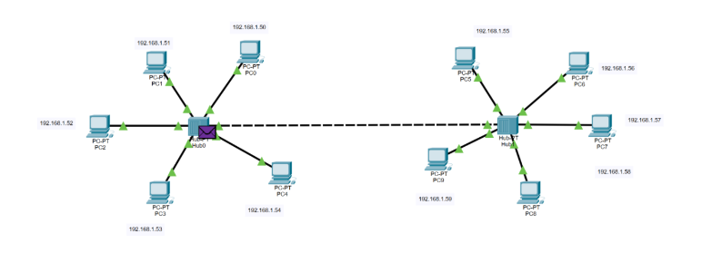

“Hub0” sends the packet to all other immediate network devices including “Hub1”. If other devices  are not the receiving devices, then the packet is rejected.

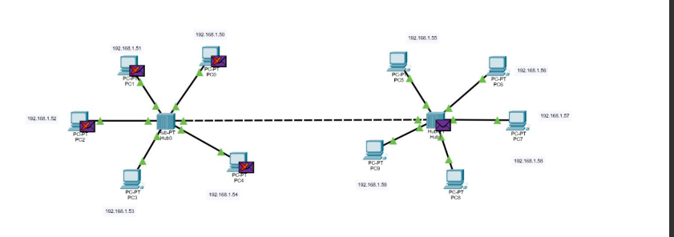

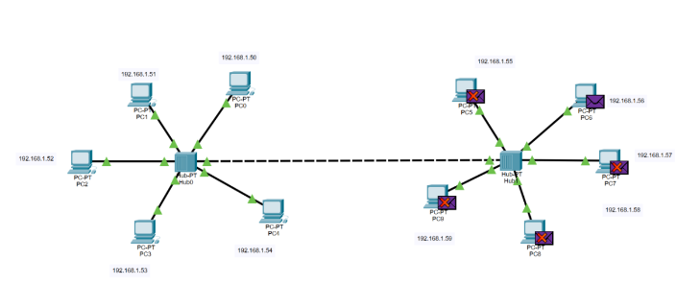

Then “Hub1” sends the packet to all its immediate end devices. End devices other than the intended  recipient rejects the packet.

The recipient then sends acknowledgement message to its immediate hub i.e. “Hub1”.

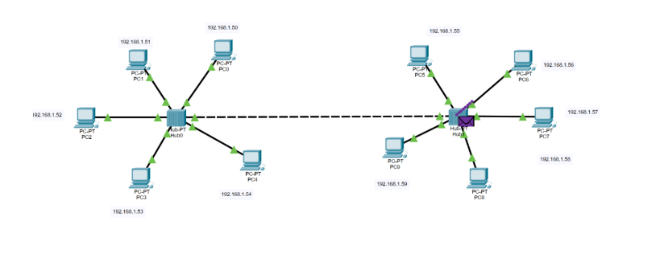

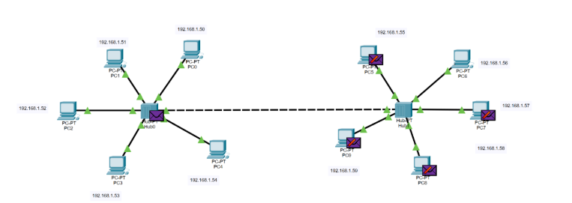 “Hub1” sends acknowledgement message to its immediate network devices. Since the end devices  in second network are not the sender they reject the acknowledgement message.

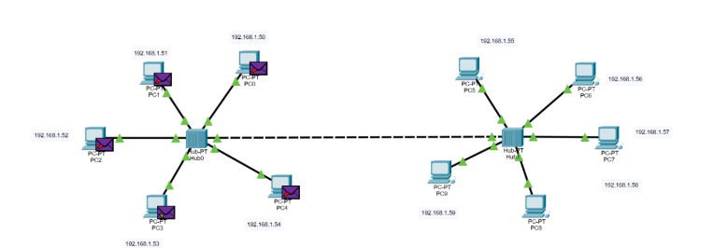

“Hub0” sends the acknowledgement message to its immediate end devices and the message is  received by sender only i.e. “Laptop3”.

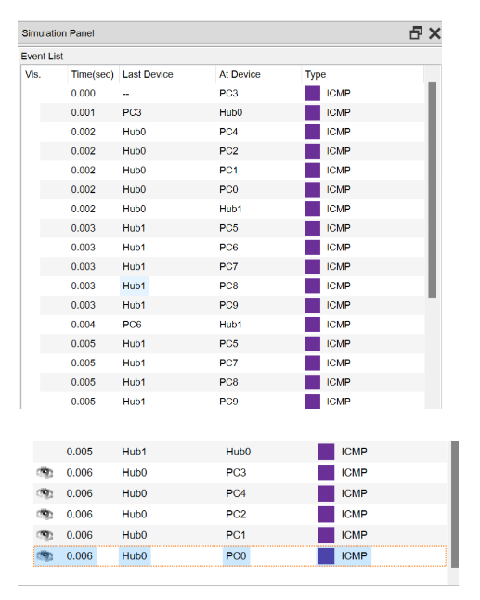

**Difference between hub and switch relating the above simulation  scenario:**

In the star topology simulation scenario where both a hub and a switch are used, the switch efficiently forwards frames to the specific PC for which the frame is intended based on its MAC address table. In contrast, the hub broadcasts incoming frames to all PCs connected to it, irrespective of the destination.

The use of a switch in the network design enhances performance by reducing unnecessary traffic and collisions, whereas the hub increases broadcast traffic and potential network congestion.

The switch learns the MAC addresses of devices connected to its ports and forwards frames selectively based on MAC address tables. Frames are only forwarded to the port where the destination device is connected. Consequently, hub Simply amplifies and broadcasts the incoming electrical signals to all its ports. When a frame is received on one port, it is sent out on all other ports.

Overall, the switch provides a more optimized and scalable solution for the star topology network, ensuring better performance and reduced network overhead compared to the hub.

**Conclusion**

In our simulation with Cisco Packet Tracer, we set up a star network using a hub and a switch. The hub sent data to all devices, causing more traffic. In contrast, the switch sent data only where needed, making it more efficient. The switch performed better, but it's pricier than the hub.